

FINISHED PRODUCT SPECIFICATION SHEET



HairTite XL Beard Snood

Material Polypropylene 56 decitex
(ISO 9001 accredited supplier)

Elastic Nylon covered rubber. Min. 3x stretch

Width (qty of yarn strands) 103

Size (stretched) 43cm

Fabric Structure HairTite HiCare

Weight 3 grams

Dye Fastness 4/5 grey scale C06A2S

Metal Detectable Same cost option for due diligence

Quantities Inner Outer Case
36 pcs packed loose in polybag

Features and Benefits: HairTite Beard Snood

- Independently tested for hair containment by the University of Bolton UK
  - 2 X better hair containment than a traditional 5mm mesh beard net
- Only hair containment product to be certified and approved by HACCP International as suitable for use within food processing and food service environments
- Tested for harmful substances in accordance with Oeko-Tex Standard 100
- Mesh used is Flame retardant to BSEN ISO 1021 – 1:2006
- Contains Prolen: moisture wicking properties for optimum wearer comfort and temperature regulation
- Available metal free and metal detectable

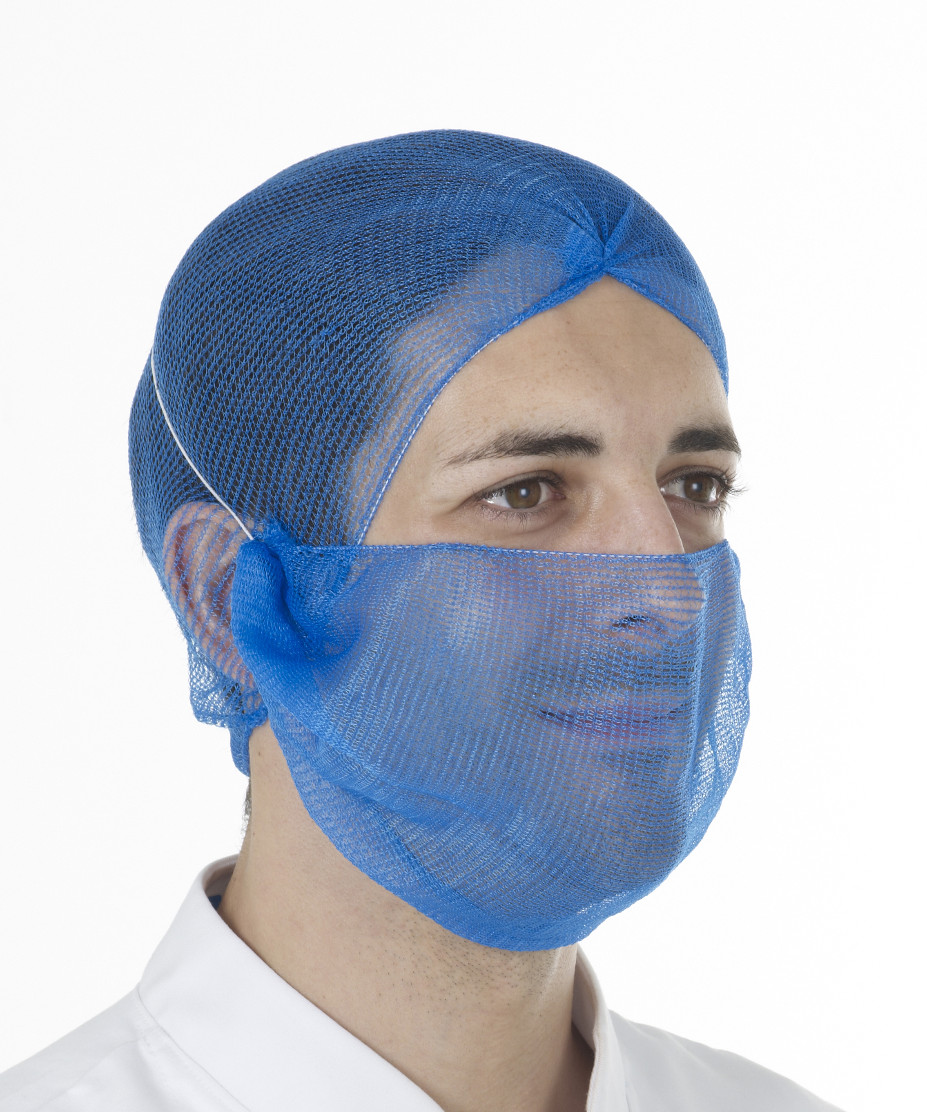
For optimum hair containment read the White Paper Target Zero Hair Complaints: www.aburnet.co.uk/target-zero-hair-complaints/

